Unit 2 Links to Kahoots and Unit Tests

Flowchart Shapes | https://create.kahoot.it/share/firia-labs-ap-csp-flowchart-shapes/883d78ee-287d-46b9-bfdb-935a958f6320
Mission 6 | https://create.kahoot.it/share/firia-labs-mission-6/7bf069b2-892b-4db9-89f7-10738cbdbc63
Mission 7 | https://create.kahoot.it/share/firia-labs-mission-7/06203065-5a87-41df-8449-e6381da62196
Mission 8 | https://create.kahoot.it/share/firia-labs-mission-8/6df93bf9-a83a-444e-929d-65b187437f64
Unit 2 Vocabulary Review | https://create.kahoot.it/share/firia-labs-unit-2-vocab-review/f220ea96-9dba-4b97-a455-b53e6d41fc4e
Unit 2 Coding and Concepts Review | https://create.kahoot.it/share/firia-labs-unit-2-code-review/9d98b7a4-baf5-401a-bb02-ed18769d06a8
Unit 2 Vocabulary Test (MS Form) | https://forms.office.com/Pages/ShareFormPage.aspx?id=DQSIkWdsW0yxEjajBLZtrQAAAAAAAAAAAAO__SjBvJpUNUs5UUNLRFk5QkQzSUpaTjZLMVhBNUoyTi4u&sharetoken=WA3aCy361dVDomqM53gb
Unit 2 Coding and Concepts Test (MS Form) | https://forms.office.com/Pages/ShareFormPage.aspx?id=DQSIkWdsW0yxEjajBLZtrQAAAAAAAAAAAAO__SjBvJpUOVFOSUxNMzE5Mlg1OE9FVUVWMVg1VE9NQy4u&sharetoken=mCAscl69g01EGKsCP2lN

Unit 2 Question Bank: Kahoot Reviews and Microsoft Forms Exams

Flowchart Shapes Kahoot Review
What flowchart shape should be used for this code:  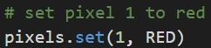 | - 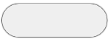 B.   C. 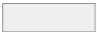 D. 
What flowchart shape should be used for this code:  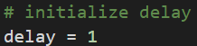 | - B.  C. D.
What flowchart shape should be used for this code:  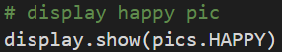 | - B.  C. D.
What flowchart shape should be used for this code:  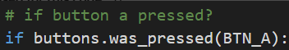 | - B.  C. D.
What flowchart shape should be used for this code:  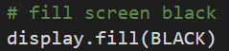 | - B.  C. D.
What flowchart shape should be used for this code:  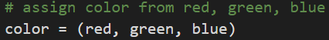 | - B.  C. D.
What flowchart shape should be used for this code:  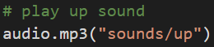 | - B.  C. D.
What flowchart shape should be used for this code:  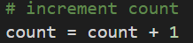 | - B.  C. D.
What flowchart shape should be used for this code:  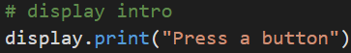 | - B.  C. D.
What flowchart shape should be used for this code:  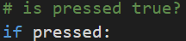 | - B.  C. D.
What flowchart shape should be used for this code:  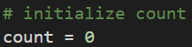 | - B.  C. D.
What flowchart shape should be used for this code:  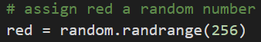 | - B.  C. D.
What flowchart shape should be used for this code:  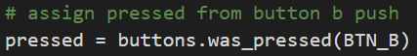 | - B.  C. D.
What flowchart shape should be used for this code:  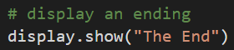 | - B.  C. D.
What flowchart shape should be used for this code:  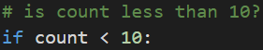 | - B.  C. D.

Mission 6 Kahoot Review
What will the code segment do?  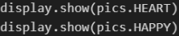 | - Display the happy face only  - Display the heart very quickly and then the happy face  - Display the heart only  - Display each image for about 1 second each
What is the definition of “loop”? | - Repeats a block of code, subject to a condition  - A series of code that runs one line at a time  - An expression that evaluates to True or False  - Decision points in code
What is the definition of “condition”? | - Repeats a block of code, subject to a condition  - A series of code that runs one line at a time  - An expression that evaluates to True or False  - Decision points in code
What is the data type of this value: ‘robot’ | - Integer  - Float  - String  - Boolean
What is the data type of this value: 15 | - Integer  - Float  - String  - Boolean
What is the data type of this value: 0.5 | - Integer  - Float  - String  - Boolean
What is the data type of this value: True | - Integer  - Float  - String  - Boolean
What does the ‘break’ statement do? | - Causes the code to stop  - Crashes the program  - Jumps over the next line of code  - Breaks out of the loop
What is the correct code for using a break statement? | - 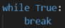 B. 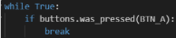  C. 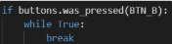 D. 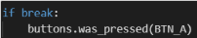
What is “increment”? | - Assigning a value to a variable  - Causing an error in code  - Increasing the value of a variable by a set amount  - Decreasing the value of a variable by a set amount
What is “decrement”? | - Assigning a value to a variable  - Causing an error in code  - Increasing the value of a variable by a set amount  - Decreasing the value of a variable by a set amount
What is the final value of ‘number’?  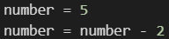 | - number = 5  - number = 2  - number = 3  - An error occurs
What code will increment ‘number’ by 1? | - number = value + 1  - number = number + 1  - number = number - 1  - value = number + 1
Why does the heartbeat blink slower when you add time? | - A larger delay in the loop cycle makes a slower blink rate  - A smaller delay in the loop cycle makes a slower blink rate  - Positive numbers are always slower than negative ones  - Larger hearts beat slower than smaller ones
Why do you get a runtime error when you decrement ‘delay’ too many times? | - The display can’t run that fast  - Too small a delay creates a time vortex  - The CodeX can’t keep up with too many button presses  - The delay will go below 0 and sleep() can’t handle negative numbers

Mission 7 Kahoot Review
What does this code do? | - Compares choice to 0, branching when choice is less than 0  - Gives an error message  - Compares choice to 0, branching when choice is equal to 0  - Assigns the variable choice the value 0
What does this code do? | - Compares choice to 0, branching when choice is less than 0  - Gives an error message  - Compares choice to 0, branching when choice is equal to 0  - Assigns the variable choice the value 0
What does this code do? | - Compares choice to 0, branching when choice is less than 0  - Gives an error message  - Compares choice to 0, branching when choice is equal to 0  - Assigns the variable choice the value 0
What is the result if BTN_R is pressed?  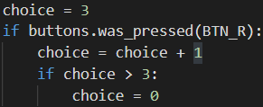 | - ‘choice’ is assigned the value 0  - ‘choice’ is assigned the value 4  - ‘choice’ is assigned the value 3  - An error occurs
What code will give the number of items in a list? | - str(my_list)  - items(my_list)  - get_items(my_list)  - len(my_list)
What is the first index of every list? | - 0  - 1  - A  - len(my_list) - 1
What is the last index of every list? | - len(my_list)  - Depends on the number of items  - Z  - len(my_list) - 1
Given this list, what are the values of the index?  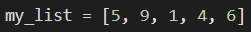 | - 1, 2, 3, 4, 5  - 5, 9, 1, 4, 6  - 0, 1, 2, 3, 4  - len(my_list)
Given this list, what is the value of my_list[0]? | - 5  - 9  - 6  - An error occurs
Given this list, what is the value of my_list[1]? | - 5  - 9  - 1  - An error occurs

Mission 8 Review Kahoot
What is the definition of “list”? | - A number that keeps track of what item is accessed  - An individual element in a list  - A sequence of items you can access with an index  - A built-in function that gets a random number
What is the definition of “index”? | - A number that keeps track of what item is accessed  - An individual element in a list  - A sequence of items you can access with an index  - A built-in function that gets a random number
What is the definition of “item”? | - A number that keeps track of what item is accessed  - An individual element in a list  - A sequence of items you can access with an index  - A built-in function that gets a random number
Given the code, what is the ‘count’ variable doing?  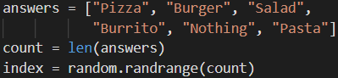 | - Automatically scans the list and returns the number of items  - Stores the number of items in the list to use in the randrange function  - Selects an item from the list and displays it on the screen  - Selects a random number between 0 and the number of items in the list
Given the code, what is the ‘index’ variable doing? | - Automatically scans the list and returns the number of items  - Stores the number of items in the list to use in the randrange function  - Selects an item from the list and displays it on the screen  - Selects a random number between 0 and the number of items in the list
How can you change the size of text when displayed? | - display.print(text, scale=3)  - display.scale(text, 3)  - display.show(text, size=3)  - display.print(text, size=3)
Given this command, what are the possible values of ‘index’? | - 1, 2, 3, 4  - 0, 1, 2, 3  - 0, 1, 2, 3, 4  - An error will occur
Which command will give a random number between 0 and 6? | - random.randrange(6)  - random.randrange(5)  - random.randrange(7)  - random.randrange(0, 6)
What does this command do? | - Selects a random item from list “answers”  - Selects a random item from “my_choice”  - Selects a random number between 0 and 6  - Will cause an error
What is the result of this code?  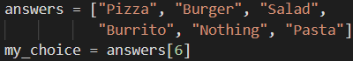 | - Assigns my_choice the value 6  - Assigns my_choice the value “Pasta”  - Assigns my_choice a random item from the answers list  - Will cause an error

Additional questions are provided below for the supplemental lessons: Design Process, Flowcharts and Lists

Unit 2 Vocabulary (Kahoot Review and Unit 2 Exam)
Select the best computer science definition for each vocabulary word
Loop | - A series of instructions that runs one line at a time  - Decision points in code  - Repeats a block of code, subject to a condition  - An expression that evaluates to True or False
Condition | - A series of instructions that runs one line at a time  - Decision points in code  - Repeats a block of code, subject to a condition  - An expression that evaluates to True or False
While Loop | - A loop that never ends because the condition is always True  - Repeats a block of indented code as long as the condition is true  - Executes a block of code, subject to a condition  - An expression that evaluates to True or False
Infinite Loop | - A loop that never ends because the condition is always True  - Repeats a block of indented code as long as the condition is true  - Executes a block of code, subject to a condition  - An expression that evaluates to True or False
Float | - An integer number  - A decimal number  - Some text  - Something that is True or False
Increment | - Assigning a value to a variable  - Causing an error in code  - Increasing the value of a variable by a set amount  - Decreasing the value of a variable by a set amount
Decrement | - Assigning a value to a variable  - Causing an error in code  - Increasing the value of a variable by a set amount  - Decreasing the value of a variable by a set amount
List | - A number that keeps track of what item should be displayed  - An individual element or value  - A sequence of elements you can access with an index  - A built-in function that gets a random number
Index | - A number that keeps track of what item should be displayed  - An individual element or value  - A sequence of elements you can access with an index  - A built-in function that gets a random number
Item | - A number that keeps track of what item should be displayed  - An individual element or value  - A sequence of elements you can access with an index  - A built-in function that gets a random number

Unit 2 Concepts and Coding (Kahoot Review)
What is the data type of this value: ‘coding’ | - Integer  - String  - Float  - Tuple
What is the data type of this value: 7 | - Integer  - String  - Float  - Boolean
What is the data type of this value: 1.2 | - Integer  - String  - Float  - Boolean
a.What is the data type of this value: False | - Tuple  - String  - Float  - Boolean
What is the data type of this value: GREEN | - Tuple  - String  - Float  - Boolean
What code will decrement ‘number’ by 1? | - number = value + 1  - number = number - 1  - number = number + 1  - value = number - 1
What is the correct code for using a break statement? | - B.  C. D.
What does this code do? | - Compares choice to 0, branching when choice is less than 0  - Gives an error message  - Compares choice to 0, branching when choice is equal to 0  - Assigns the variable choice the value 0
What does this code do? | - Compares choice to 0, branching when choice is less than 0  - Gives an error message  - Compares choice to 0, branching when choice is equal to 0  - Assigns the variable choice the value 0
What is the result if BTN_R is pressed?  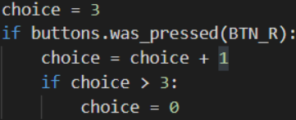 | - ‘choice’ is assigned the value 0  - ‘choice’ is assigned the value 4  - ‘choice’ is assigned the value 3  - An error occurs
What code will give the number of items in a list? | - str(my_list)  - items(my_list)  - get_items(my_list)  - len(my_list)
What is the first index of every list? | - 0  - 1  - A  - len(my_list) - 1
What is the last index of every list? | - len(my_list)  - Depends on the number of items  - Z  - len(my_list) - 1
Given this list, what are the values of the index? | - 1, 2, 3, 4, 5  - 5, 9, 1, 4, 6  - 0, 1, 2, 3, 4  - len(my_list)
Given this list, what is the value of my_list[0]? | - 5  - 9  - 1  - An error occurs
Given the code, what is the ‘count’ variable doing? | - Automatically scans the list and returns the number of items  - Stores the number of items in the list to use in the randrange function  - Selects an item from the list and displays it on the screen  - Selects a random number between 0 and the number of items in the list
Given the code, what is the ‘index’ variable doing? | - Automatically scans the list and returns the number of items  - Stores the number of items in the list to use in the randrange function  - Selects an item from the list and displays it on the screen  - Selects a random number between 0 and the number of items in the list
Given this command, what are the possible values of ‘index’? | - 1, 2, 3, 4  - 0, 1, 2, 3  - 0, 1, 2, 3, 4  - An error will occur
What does this command do? | - Selects a random item from list “answers”  - Selects a random item from “my_choice”  - Selects a random number between 0 and 6  - Will cause an error
What is the result of this code? | - Assigns my_choice the value 6  - Assigns my_choice the value “Pasta”  - Assigns my_choice a random item from the answers list  - Will cause an error

Unit 2 Concepts and Coding (Unit 2 Exam)
What is the best data type for this value: True | - Integer  - Float  - String  - Boolean  - tuple
What is the best data type for this value: 3.15 | - Integer  - Float  - String  - Boolean  - tuple
What is the best data type for this value: 10 | - Integer  - Float  - String  - Boolean  - tuple
What is the best data type for this value: YELLOW | - Integer  - Float  - String  - Boolean  - tuple
What is the best data type for this value: “debug” | - Integer  - Float  - String  - Boolean  - tuple
What code will increment the variable count by 1? | - number = value + 1  - number = number + 1  - value =number + 1  - number = number - 1
What is the correct code for using a break command? | - 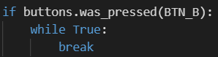 c) 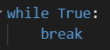  - 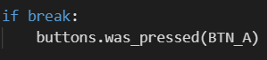 d) 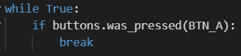
What does this code do? | - Compares choice to 0, branching when choice is more than 0  - Gives an error message  - Compares choice to 0, branching when choice is equal to 0  - Assigns the variable “choice” the value 0
What does this code do?  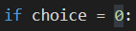 | - Compares choice to 0, branching when choice is more than 0  - Gives an error message  - Compares choice to 0, branching when choice is equal to 0  - Assigns the variable “choice” the value 0
What is the result if BTN_B is pressed?  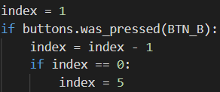 | - index = 1  - index = 0  - index = 5  - An error occurs
What code will give the number of items in a list? | - str(my_list)  - int(my_list)  - len(my_list)  - get_items(my_list)
What value is always the FIRST index of every list? | - 1  - 0  - A  - len(my_list) - 1
What value is always the LAST index of every list? | - 1  - 0  - A  - len(my_list) - 1
Given this list, what are the possible values of the index?  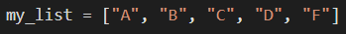 | - 0, 1, 2, 3, 4  - 1, 2, 3, 4, 5  - A, B, C, D, F  - len(my_list) - 1
Given the list, what is the item at my_list[2] ? | - “A”  - “B”  - “C”  - “D”
Given this code, what is the “count” variable doing?  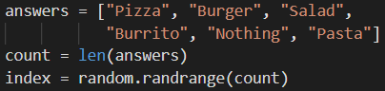 | - Stores the number of items in the list to use in the randrange function  - Selects an item from the list and displays it on the screen  - Automatically scans the list and returns the number of items  - Selects a random number between 0 and the number of items in the list
Given this code, what is the “index” variable doing? | - Stores the number of items in the list to use in the randrange function  - Selects an item from the list and displays it on the screen  - Automatically scans the list and returns the number of items  - Selects a random number between 0 and the number of items in the list
Given this code, what are the possible values of “number”? | - 1, 2, 3, 4, 5  - 0, 1, 2, 3, 4, 5  - 0, 1, 2, 3, 4  - An error will occur
What does this command do? | - Assigns “answer” a random item from “my_choice”  - Assigns “my_choice” a random item from “answers”  - Assigns “my_choice” a random number between 0 and “answers”  - Will cause an error
What is the result of this code:  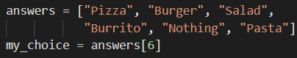 | - Assigns “my_choice” the value 6  - Assigns “my_choice” the value “Pasta”  - Assigns “my_choice” a random item from the list “answers”  - Will cause an error

Questions for Supplemental Lessons – Design Process, Flowcharts, and Lists
Vocabulary: Select the best computer science definition for each vocabulary word
Design process | - A tool that helps you break down large projects into smaller stages  - A diagram that uses shapes to sequence steps  - A sequence of steps for completing a task  - A code segment that accomplishes a specific task
Algorithm | - A tool that helps you break down large projects into smaller stages  - A diagram that uses shapes to sequence steps  - A sequence of steps for completing a task  - A code segment that accomplishes a specific task
Flowchart | - A tool that helps you break down large projects into smaller stages  - A diagram that uses shapes to sequence steps  - A sequence of steps for completing a task  - A code segment that accomplishes a specific task
Coding and Concepts Questions
What is the third step in the design process? | - Research solutions  - Plan a solution  - Code the solution  - Document and reflect
What is the fourth step in the design process? | - Research solutions  - Plan a solution  - Code the solution  - Document and reflect
What is the fifth step in the design process? | - Research solutions  - Plan a solution  - Code the solution  - Document and reflect
What flowchart shape is used for making decisions? | - B.  C. D.
What flowchart shape is used for beginning and ending the program? | - B.  C. D.
What flowchart shape is used for an action or process? | - B.  C. D.
What flowchart shape is used for input and output? | - B.  C. D.
What code defines an empty list? | - a_list = []  - a_list = ()  - a_list = {}  - a_list.new()
Given the list, what is the value of my_list[6]? | - 2  - 8  - 3  - Index out of range error
Given this code, what is the new value of my_list[3]?  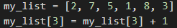 | - 3  - 2  - 8  - 6
Which Python method adds an element at the end of the list? | - pop()  - add()  - append()  - insert()
Which Python method adds an element at a given index? | - pop()  - add()  - append()  - insert()
Which Python method removes the element at a given index? | - pop()  - remove()  - append()  - insert()
What is the length of the list after the code segment is executed?  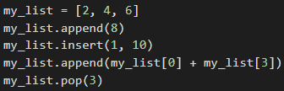 | - 3  - 6  - 7  - 5
What is my_list[3] after the code segment is executed? | - 2  - 4  - 6  - 8
What is the value of my_list after the code segment is executed?  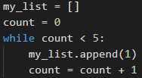 | - my_list = [5]  - my_list = [1, 1, 1, 1, 1]  - my_list = [0, 1, 2, 3, 4]  - my_list = [0, 0, 0, 0]

